10 Computer Repair Tricks To Make Your Slow PC Run Faster

If you're like most people these days, you "speak" to your computer first thing in the morning and last thing at night. This is our lifeline and financial support for many of us now. So it's quite aggravating when it begins moving slower than my hubby.

If you're having problems with Windows 7, 8, or 10, we'd like to provide some advice on how to deal with a sluggish PC. It'll save you a lot of aggravation and stress, keep your blood pressure in check, and get you back on your feet:

How to Make Your Computer Run Faster

- Uninstall any programmes you aren't using:

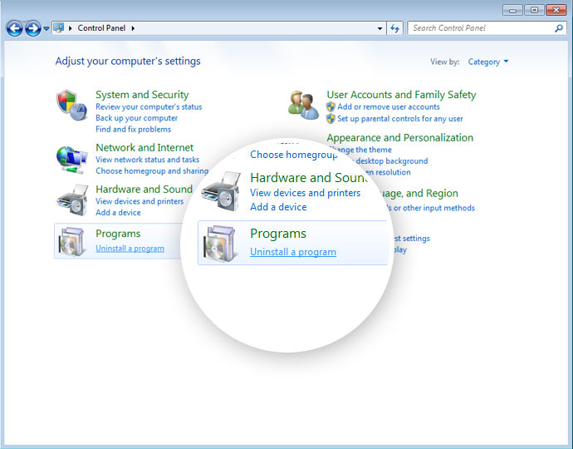

New PCs come with pre-installed programs, and the chances are you’re not going to use them, and they slow your computer down from day one, and they keep adding to it. Often referred to as bloatware, crapware, junkware, and is often self-advertising for whoever you purchase your computer.
It may be a joint effort between the big box store and a software company, co-op advertising. Old computers can accrue these over time. Many of these you will never use, and many of them are running in the background constantly without you being aware of them. They are slowing your computer down.
To remove this bloatware, either the day you buy your computer or afterward, follow these steps: Start>Control Panel>Programs and Features. Then scroll down the list, then uninstall the ones you won’t use. There are software programs that can help you choose which ones are practical for you.
- Temporary Measure: Delete
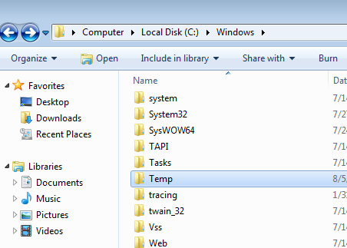

An old webcam can be used to create your home security system. It's easy to set it up. Once you have the software installed, you can go about your normal day until alerts are sent or press a button. You can now use your old computer as a monitor for security cameras to be checked and monitored.

- The HardDrive: Stable and Powerful
The hard disc might be the issue if your computer takes ages to turn on or load up. Because there are so many moving parts, they take longer to start going. If you switch to flash memory, your computer will start up faster since the data will be read faster.
- Increase the Storage:
Even if you keep your computer clean and neat, the hard drive will fill up and slow it down, especially if you do a lot of media and video recording. Purchase a 1TB mega storage disc to free up space on your PC for those recordings.
- Clean Your Startup Programs:
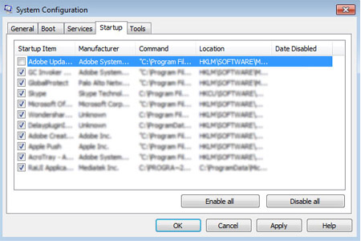
Your computer has automatic start programmes that run every time you turn it on. There's no need to start them up automatically if you don't utilise them every day. Follow these methods to clean out the ones you don't use: Start > RUN > MSConfig > Click "startup" tab" and uncheck the ones that aren't required for your everyday activities. The antivirus programme may be left alone.
- Increase the RAM:
Do you use many apps at the same time, such as your email, a web browser, and Word? When switching from one to the other, does your computer pause? You may address this problem by upgrading the RAM for a little cost.
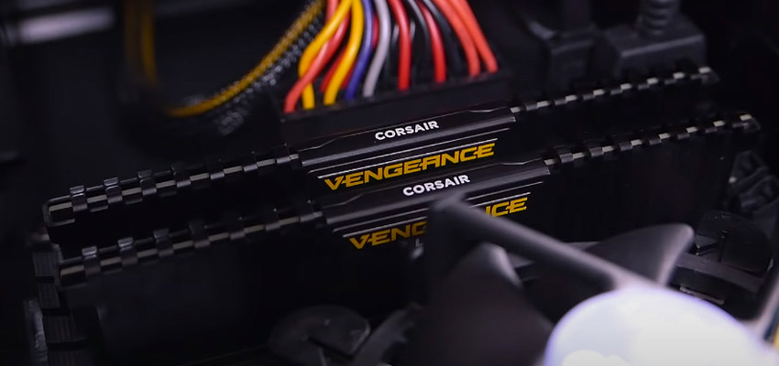
- Run Disk Defragment Tool:
It may appear frightening, but it isn't. It's a simple approach to improve the performance of your hard disc. Take the following steps: Right-click on the hard disc in My Computer>Properties>Tools>Defragment Now.

- Run Disk Cleanup Tool:
With the following procedures, you may give your computer a spring cleaning:
Accessories > System Tools > Disk Cleanup > Start > All Programs > Accessories > Disk Cleanup.
- Dust & Vacuum:
Your computer should be dusted and vacuumed on a regular basis. The cooling fan on computers collects a lot of dust, which clogs the airflow. Because a computer performs best when it is cool, the airflow in your computer or laptop must be clean to prevent it from overheating and slowing down.
Wait thirty minutes after turning off your computer. Suck out the dust inside your computer with your home vacuum on the lowest setting with extreme caution. Another approach is to use canned air once a week to blast out dust.
- New Computer: Buy a new one
If your computer is getting on in years, it may be time to upgrade. Tablets are the greatest thing these days, therefore computers and their components, as well as desktops and laptops, are less expensive than they were a few years ago.
M6 Repairs is your go-to option for computer repair on both PCs and Macs. M6 Repairs' licenced technicians can provide top-notch computer repair, laptop repair, and technical assistance to help you fix any bothersome PC difficulties.

